Trevor Larrabure

Course 4 End Project 1
Creating a Front-end Starter Code for a Taxi Ride Booking Application Using Generative AI

Here are the screen shots of the project.

HOME PAGE
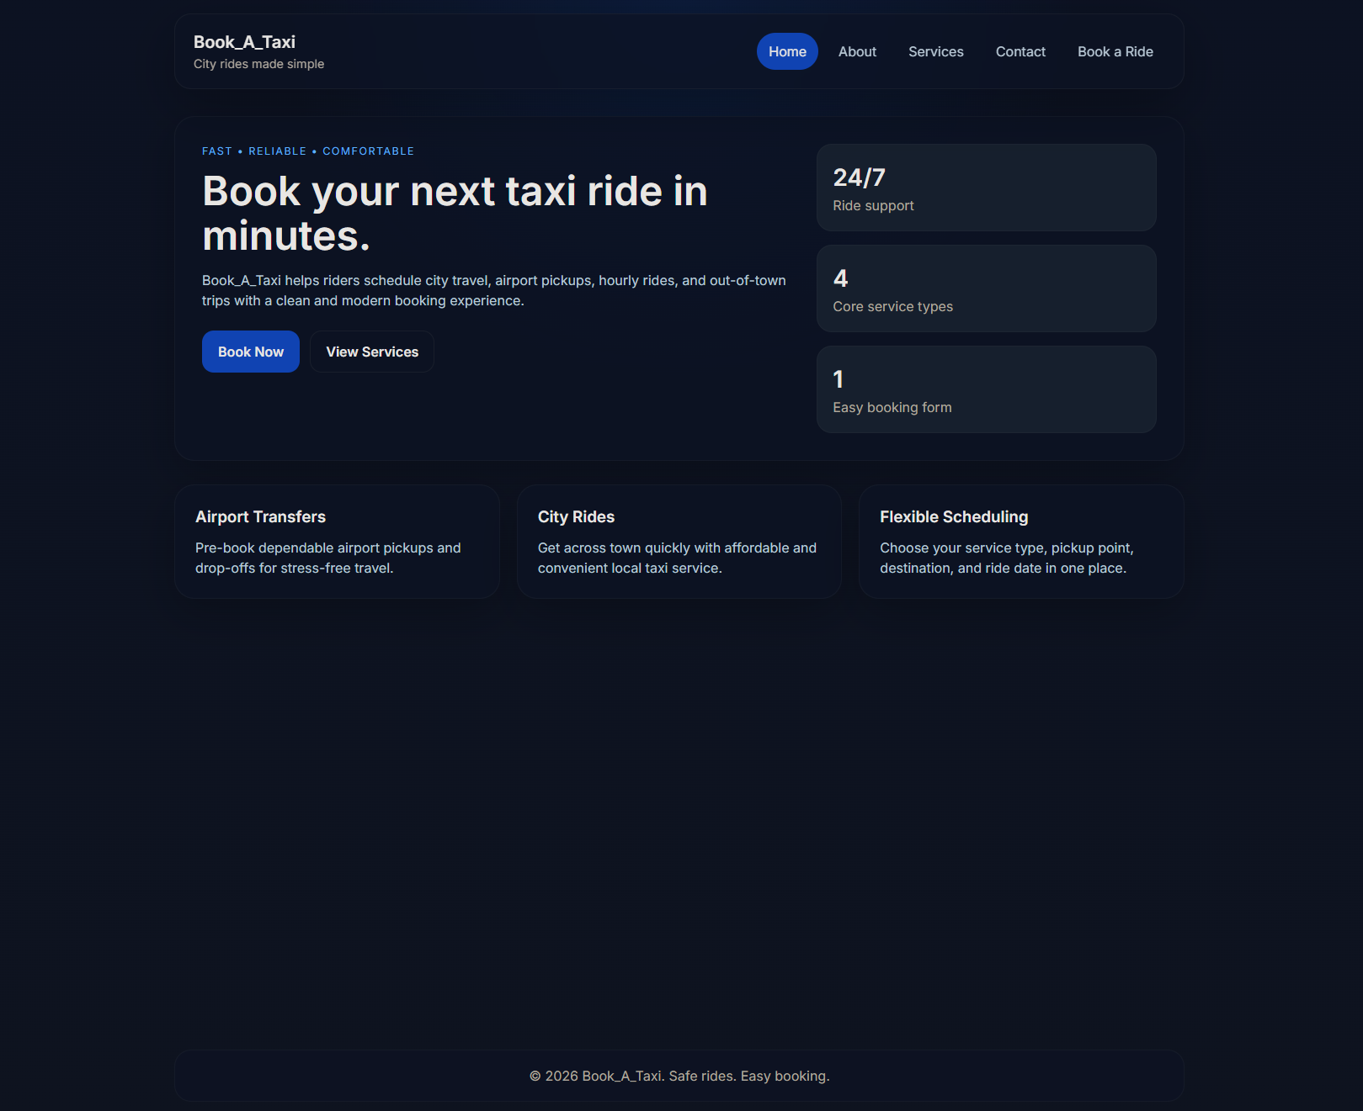

ABOUT PAGE
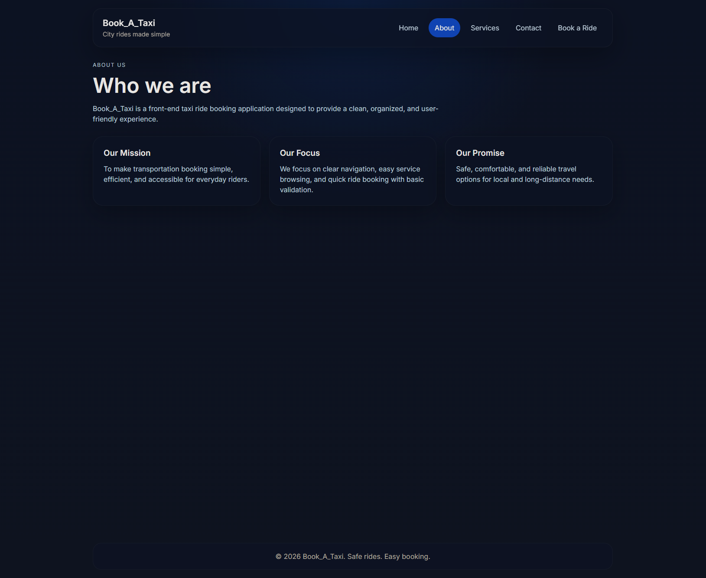

SERVICES PAGE
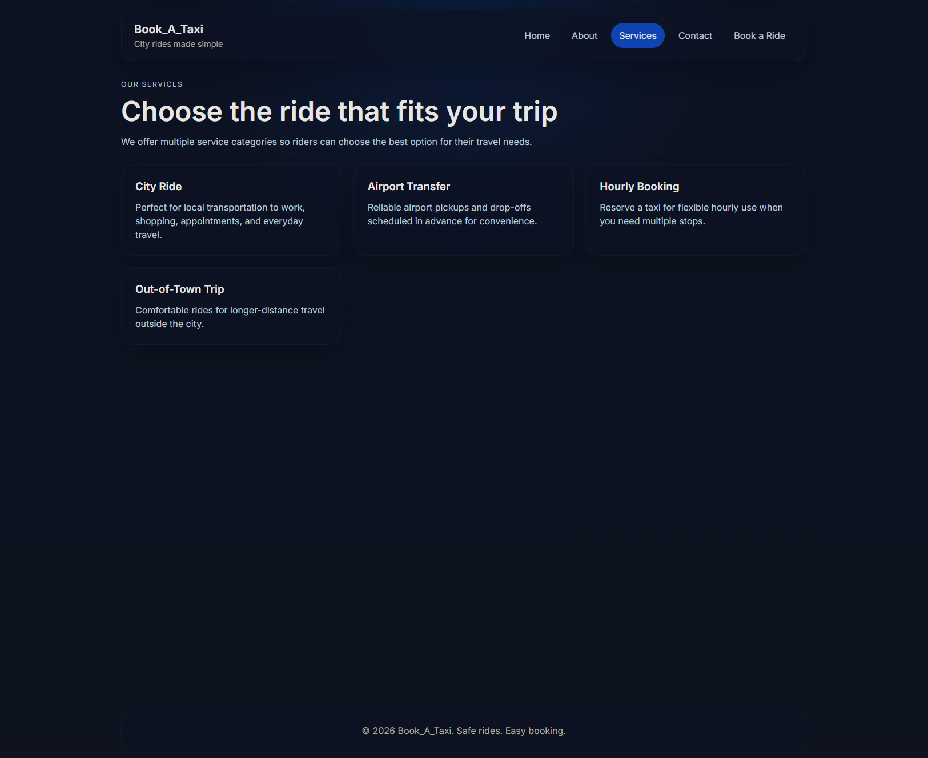

CONTACT PAGE
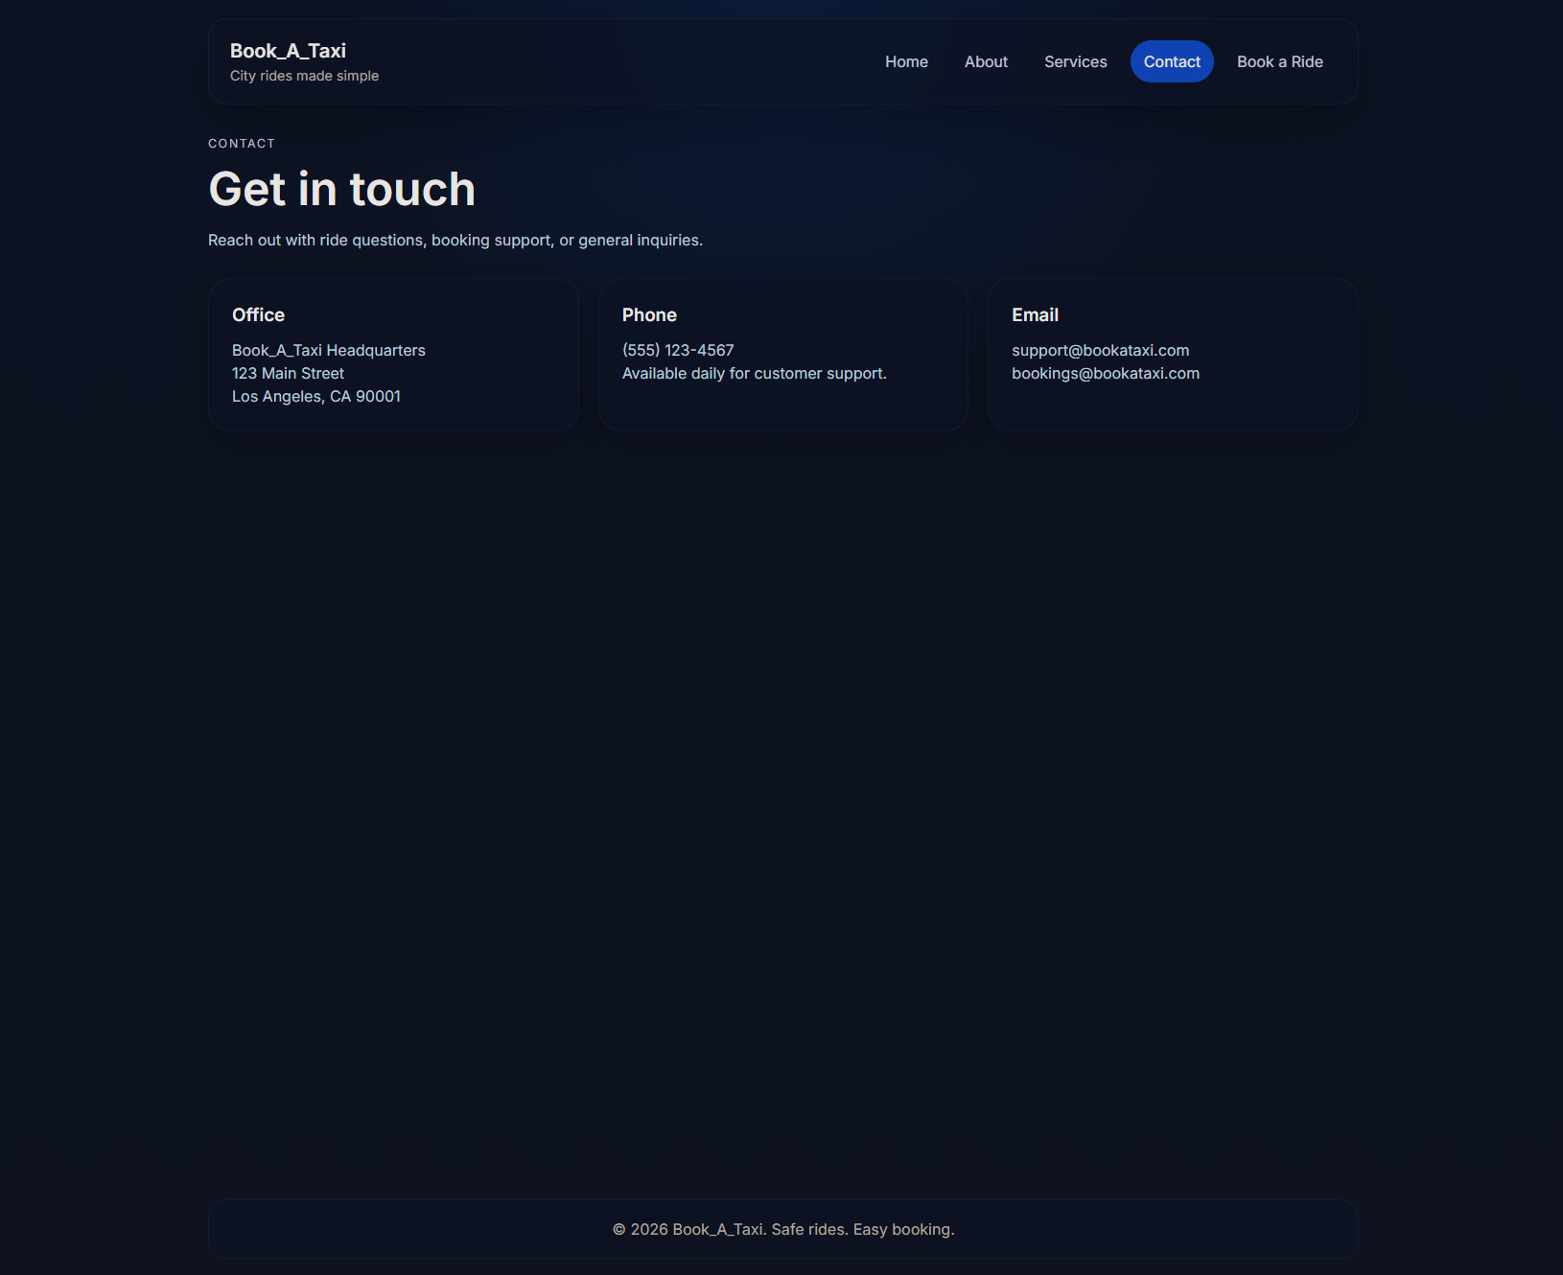

BOOK A RIDE PAGE
